MUST READ DEPLOYMENT FILES OF FastAPI

- MERN stands for MongoDB, Express.js, React.js, and Node.js.
- It’s a full-stack JavaScript technology → meaning you can build frontend + backend + database using only JavaScript.
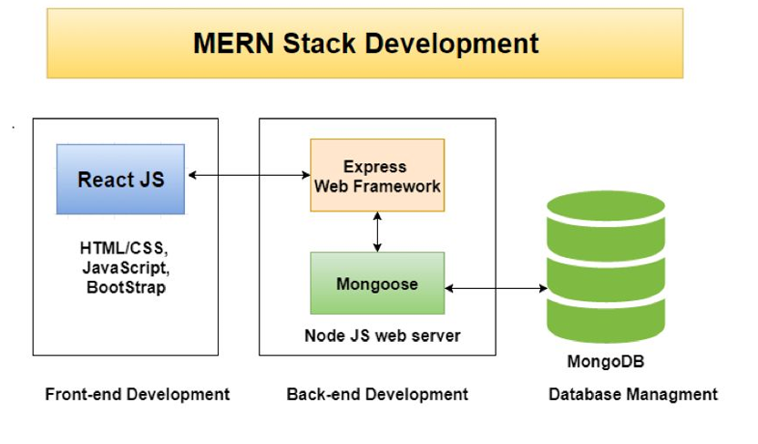

1. What is FastAPI?
Simple Definition
FastAPI is a modern, high-performance Python framework used for building APIs and backend applications.
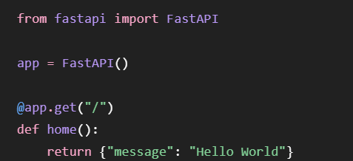
3. What are the main features of FastAPI?
The important features are:
- High Performance
- Automatic API Documentation
3. Data Validation
FastAPI uses Pydantic for validating request data.
4. Async Support

4. What are the advantages of FastAPI over Flask?
FastAPI | Flask
Modern API-focused framework | Lightweight general-purpose web framework
Supports async functions | Supports sync functions
Both are Python web frameworks, but they have different strengths.
Contains Automatic API Documentation Doesn’t provide automatic API Documentation
Built-in validation using pydantic Doesn’t contain built-in validations

5. What are the advantages of FastAPI over Django?
Django and FastAPI are both popular Python web frameworks
Django is a full-featured framework that comes equipped with almost everything you need to build an enterprise web application right away.
FastAPI is modern,high-performance framework which provides core routing and validation features

6. What is ASGI?
ASGI = Asynchronous Server Gateway Interface
ASGI is a standard interface that connects applications with web servers which supports asynchronous communication

7. What is Uvicorn?
Simple Definition
Uvicorn is an ASGI web server used to run FastAPI applications.

8. How do you run a FastAPI application?
From fastapi import FastAPI
app=FastAPI()
@app.get(‘\’)
def home():
return {“FastAPI is running!”}
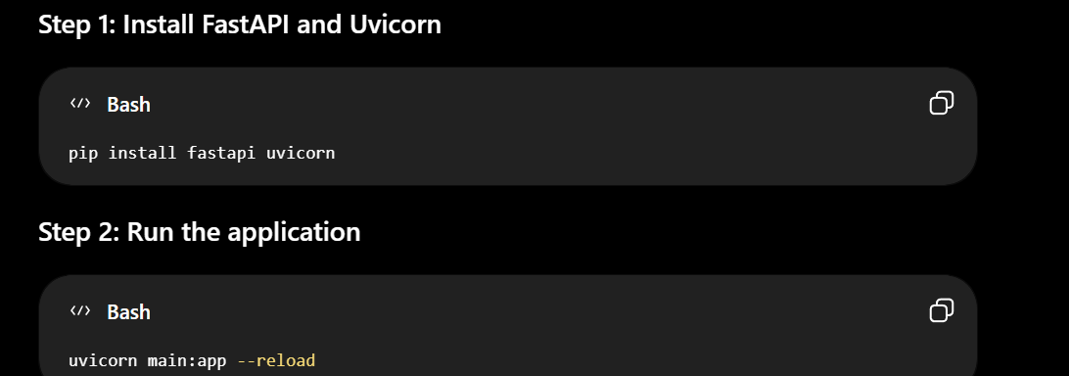
1. What is an API?
Simple Definition
API stands for Application Programming Interface.
An API allows two different software applications to communicate with each other.

2. What is a REST API?
REST
REST stands for Representational State Transfer.
"A REST API is an API that typically uses HTTP methods such as GET, POST, PUT, PATCH, and DELETE to perform operations on resources."

3. What is the difference between REST and SOAP?
REST and SOAP are two types of APIs
SOAP uses XML Formats to facilitate communication between frontend and backend
Whereas
REST uses HTTP methods

4. What HTTP methods are commonly used in FastAPI?
HTTP methods are the Request commands that tell a server what action to perform
Answer:
- GET → Retrieve data
- POST → Create data
- PUT → Update entire data
- PATCH → Update partial data
- DELETE → Remove data
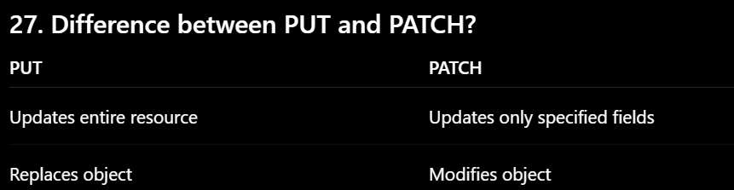
Q8. What are routes?
Answer:
Routes are the endpoints that performs specific task
25. What is Routing?
Answer:
Routing is a mechanism where specific endpoints gets executed based on the user HTTP Requests and commands

6. How do you create a GET endpoint?
Use the @app.get() decorator.
7. How do you create a POST endpoint?
Use the @app.post() decorator.

1. What is a Path Parameter?
A path parameter is part of the URL used to identify specific resource
GET /students/10 #Here 10 is the Path Parameter

2. What is a Query Parameter?
A query parameter is a value placed after ? in the URL.
It is commonly used for:
- Filtering
- Searching
- Sorting


3. Difference Between Path Parameters and Query Parameters
This is a very common interview question.
Path Parameter | Query Parameter
Part of the URL path | Comes after ?
Usually identifies a specific resource | Usually filters/customizes results

21. What is Pydantic?
Simple Definition
Pydantic is a Python library used for data validation
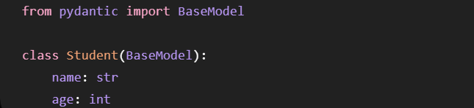
23. What is a Pydantic Model?
A Pydantic model is a Python class that inherits from BaseModel and defines the structure and data types of input data

24. How does FastAPI perform data validation?
FastAPI uses Pydantic models to validate incoming data.

25. How do you define optional fields in Pydantic?
In modern Pydantic, use Optional with None.
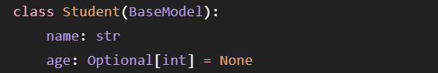
26. How do you define default values?
Simply assign a value after the data type
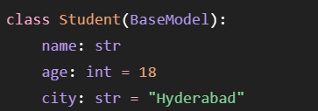
27. What happens when invalid data is sent to an API?
FastAPI validates the request using the defined Pydantic model.
If validation fails, FastAPI does not execute the endpoint function and returns a validation error response, commonly with HTTP status 422 for request validation errors.

28. What is response_model in FastAPI?
response_model defines the expected structure of the response returned by an API endpoint.

29. Difference Between Request Model and Response Model
Request Model
defines the expected structure and data types of input data
Response Model
response_model defines the expected structure of the response returned by an API endpoint.

30. How do you validate an email address using Pydantic?
Pydantic provides an EmailStr type.

31. What is Dependency Injection?
Simple Definition
Dependency Injection (DI) in FastAPI is a system which automatically provides the functions with all the dependencies or external tools, database connections required to perform the task
In FastAPI, dependencies can be injected using Depends()."

22. What is Async Programming?
Answer
Asynchronous programming allows a program to perform other tasks while the intial task waiting for I/O operations such as server responses
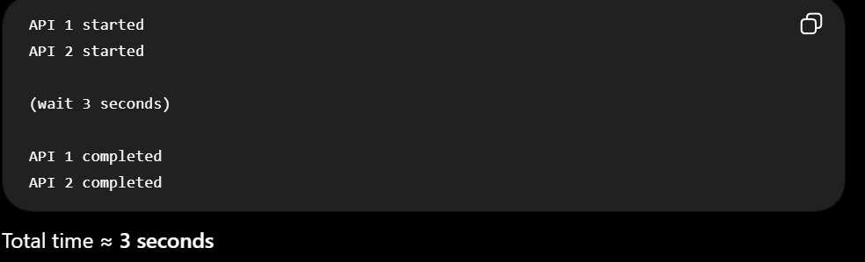
22. What is sync Programming?
Answer
Synchronous programming makes the program wait for the current task to complete before performing other tasks
Here if the initial task required wait time of 10second for server to respond,its wait and completes the task before allowing other tasks to perform
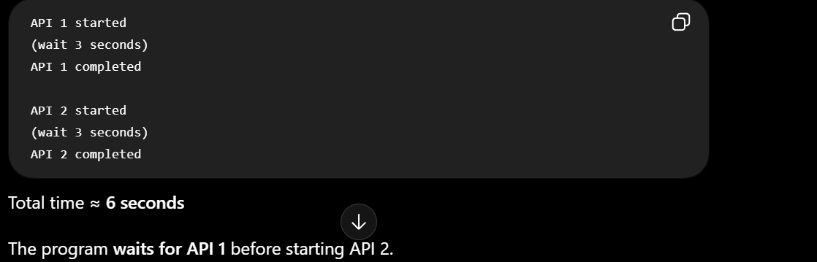

38. Difference Between async def and def
def defines a normal synchronous function.
async def defines asynchronous function

39. What is await?
Simple Definition
await is used inside an async def function
The await keyword pauses an asynchronous function until a promise or task finishes

39. What is Middleware?
Simple Definition
middleware is the code executed between the client's HTTP request and the server's final response
Common Uses of Middleware
- Authentication and Security: Checks if a user has permission to view a page or use an app before letting the request through.
- Logging and Tracking: Records details about web requests, such as the time, IP address, and errors, to help fix bugs.

42. How do you create Middleware in FastAPI?
One simple way is using:
@app.middleware decorator

1. What are CORS policies?
CORS = Cross-Origin Resource Sharing
CORS is a browser security mechanism that allows to make request from one origin to another origin and facilitate communication
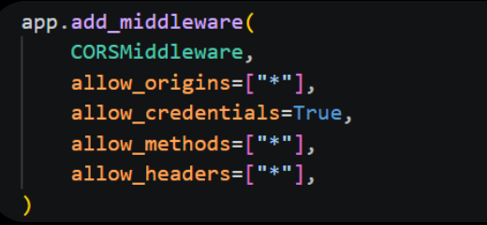
“I configured CORS in FastAPI using CORSMiddleware. I allowed cross-origin requests by configuring the allowed origins, methods, headers, and credentials. In my project, I used allow_origins=["*"] to allow requests from any origin.”

2. How do you enable CORS in FastAPI?
FastAPI provides CORSMiddleware() function

2. How do you enable CORS in FastAPI?
FastAPI provides CORSMiddleware.
from fastapi import FastAPI, HTTPException

4. What is HTTPException?
HTTPException is a class which returns an HTTP error with a specific status code and detail message.

2. How do you handle errors/exceptions in FastAPI?
FastAPI provides HTTPException class to return proper HTTP errors.
• 404 → Resource not found
• 401 → Unauthorized

3. How do you handle API errors?
6. How do you handle database failures?
Same answer as 2.

5. How do you implement authentication in FastAPI?
Authentication means:
Who are you?
Common authentication approaches include:
- JWT(Json Web Token) is a security mechanism in authenitication
- Step 1 — Login
- Step 2 — Server verifies credentials
- Step 3 — Server creates JWT
- Step 4 — Client receives token
- Step 5 — Client sends token
- Step 6 — Server verifies JWT

8. How do you connect FastAPI with MongoDB?
"I can connect FastAPI to MongoDB using a MongoDB Python driver such as the current PyMongo driver

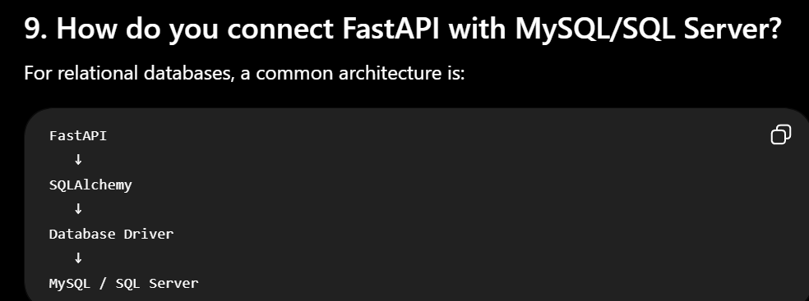
We use SQLAlchemy is a Python toolkit and Object Relational Mapper (ORM).

1. What is Motor in Python?
Simple Definition
Motor was an asynchronous Python driver for MongoDB
PyMongo now supports both synchronous and native asynchronous operations.

2. What is SQLAlchemy?
Simple Definition
SQLAlchemy is a Python SQL toolkit and ORM(Object Relational Manner) which allows Python applications to interact with relational databases

3. How do you upload a file in FastAPI?
FastAPI provides:
UploadFile class

3. What is APIRouter and why is it used?
APIRouter is class used to organize FastAPI routes into multiple modular files.
Without APIRouter, you might put everything inside:
main.py
For a large project, that becomes difficult to maintain.
Instead:
project/
│
├── main.py
├── routers/
│ ├── users.py
│ ├── products.py
│ └── auth.py

7. How do you improve FastAPI API performance?
There are several ways.
- Use asynchronous endpoints when appropriate

9. How do you deploy a FastAPI application?
Basic Deployment Architecture
Step 1: Create Requirements
Step 2: Use Environment Variables
Don't put secrets directly in code.
Step 3: Run the Application
Step 4: Deploy to Cloud

